Dale Sakaye Kunitomi
Consulting Petroleum Geologist, Camarillo, California.
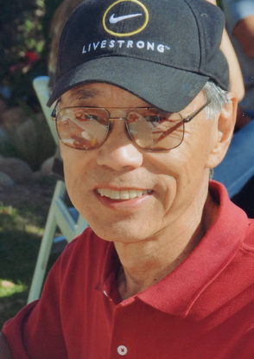
Memorial services will be held on Saturday, September 26, 12:00 pm at
Fukui Mortuary "Chapel in the Garden", 707 E. Temple St., Los Angeles, California.
www.fukuimortuary.com (213) 626-0441
Dale was born at the Heart Mountain, Wyoming, Japanese concentration camp during World War II, where he spent the first year and a half of his life. When the camp closed, his family returned to Hollywood California to rebuild their lives with Dale and his four siblings. Growing up conflicted about his family’s hardship, he found his way back to his personal history as an adult, when he attended his first Manzanar Pilgrimage in 1988.
Dale’s parents were both college graduates and longtime teachers in the LA school system. After graduation from Belmont High School, Dale enrolled in Los Angeles City College then transferred to UCLA where he discovered geology courses. After graduation he worked for and lived in the City of Long Beach, California where the easterly extension of the giant Wilmington field had just begun. During that time, he attended four years of graduate night classes at USC in an attempt to “absorb the huge volume of literature documenting the emerging Plate Tectonics Revolution”. His education at UCLA and USC resulted in episodes of schizophrenia during fall football seasons.
From Long Beach his career took him Southern California Gas Company then back in Los Angeles, Santa Barbara, Ventura and Bakersfield working for various small oil companies (Pauley, Argo, Celeron) concentrating on oil and gas exploration and development in California and Alaska. Dale’s work has also included geotechnical investigations, hydrogeologic assessments, and 3-D geologic modeling of oilfields. He became an independent consultant in 1988 working for individuals, companies, municipalities and utilities on various aspects of oil and gas geology.
Dale and Grace enjoy deep-sea fishing from their small Boston Whaler and from charter boats. They also enjoy travel to foreign lands that have included China, Kenya, Kamchatka, Alaska, Canada, Australia, and Mexico. Everywhere he goes, Dale contributes to the geological discussion.
The first presentation Dale made was to CGS in 1977 on transforming the Honor Rancho Oilfield to a Gas Storage Field after visiting the area. In 1993 Dale and Bob Michael presented on Kamchatka – The Russian Ring of Fire after a trip to the area. In 2005 he presented on Climate Change: The Paradox of Global Warming Causing A New Ice Age in a joint meeting with AEG. Dale was a CGS member and eventually an honorary member for over 45 years. Within CGS he proudly held the position of Assistant BBQ Chief under the tutelage of Dr. Eugene “Iron Chef” Fritsche. No doubt he was also proud to be CGS President in 1993-1994. He served as vice-president of the LABGS in 1976.
Dale was very active in the PSAAPG, where he was Vice President in 1999. He assisted with a successful convention held in Santa Barbara and was Convention Site Chairman for two conventions held in Ventura. Dale contributed or edited four Pacific Section publications or guidebooks and presented technical papers to the Pacific Section conventions. In 2004 Dale S. Kunitomi was chosen to receive the Distinguished Service Award presented by the Pacific Section AAPG in recognition of his contribution to and involvement with the western United States geological community. In his nomination biography, Dale wrote:
“I believe being born in the shadow of the geologic marvel of Heart Mountain, where Mississippian Madison Limestone overlies Eocene sediments, in some way influenced my life and career choices. I have been fortunate to have learned my craft from many knowledgeable geologists.”
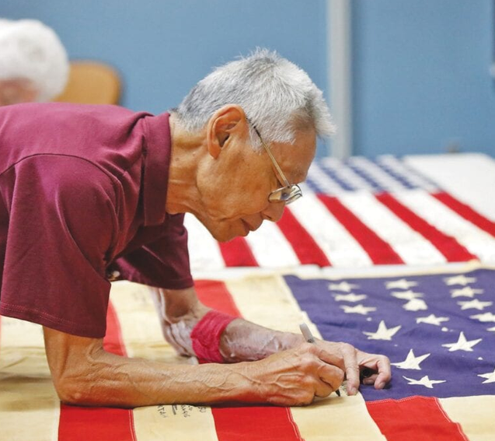
Dale is the beloved husband of Grace Marie Kunitomi; father of Damon Kunitomi; brother of Kerry Cababa, Colleen Miyano, Darrell Kunitomi, and Donald Kunitomi; sister-in-law, Betty (Mel) Bernstein; niece-in-law, Hana (Alan) Brown; he is survived by many other relatives.
Memorial services will be held on Saturday, September 26, 12:00 pm at Fukui Mortuary "Chapel in the Garden", 707 E. Temple St., Los Angeles, California.

